

**Girls’ Programming Network**

# ***Secret Diary Chatbot!***

***Part 1: Creating the Diary Chatbot***

***In this workbook, you will make a chatbot that lets you write and read the secret contents of your diary.***

***You will also add a password to keep it safe from nosy siblings or friends and lock them out if they make too many wrong guesses!***

**FOR TUTOR EYES ONLY**

# **This project was created by GPN Australia for GPN sites all around Australia!**

**This workbook and related materials were created by tutors at:**

Sydney, Canberra and Perth



Girls’ Programming Network

***If you see any of the following tutors don’t forget to thank them!!***

| **Writers** | **Testers** |
| --- | --- |
| Courtney Ross  Alex McCulloch Renee Noble | Ash Liu  Aadeeba Mou |

# **Part 0: Setting up**

| **Task 0.1: Set Up the File** |
| --- |
| Open the start menu, and type 'IDLE’. Select the IDLE 3.X version.   1. Go to the file menu and select 'new file’. This opens a new window. 2. Go to the file menu, select ’Save as’. 3. Go to the Desktop and save the file as ‘chatbot.py’. |

| **Task 0.2: You’ve got a blank space, so write your name!** |
| --- |
| At the top of the file use a comment to write your name! Any line starting with **#** is a comment.  **# This is a comment** |

| **CHECKPOINT** |
| --- |
| **If you can tick all of these off you can go to Part 1:**  ☐ You should have a file called chatbot.py  ☐ Your file has your name at the top in a comment  ☐ Run your file with F5 key and it does nothing!! |

**Today’s Project Plan:**

**Secret Diary Chatbot**

We’ll make a computer program that lets us read and write to a secret diary file. We don’t want others to read our diary so we’ll protect it with a password and secret questions.

|  | Welcome the user |
| --- | --- |
|  | Deal with if they want to read or write to the diary |
|  | Write secret messages to the diary |
|  | Read the contents of the diary |
|  | Add a secret password to the diary |
|  | Add a decoy password to trap tricksters |
| **Once your base chatbot works add cool extensions!** There’s extensions for encrypting your data with emoji, for adding tricky maths questions to protect from little siblings, and ways to make your chatbot sassier! | |

# **Part 1: Who are you?**

| **Part 1 final code** |
| --- |
| **print("Welcome to the secret diary.")**  **name = input("what is your name? ")**  **print("Hello " + name)** |

# 



| **Task 1.1: Welcome User** |
| --- |
| It’s time to welcome our user to the Secret Diary Chatbot!  **print** a welcome message.  For example:  **Welcome to the Secret Diary Chatbot!** |

| **Task 1.2: Identify yourself!** |
| --- |
| The Secret Diary Chatbot needs to know who they’re talking to.  Use **input** to ask the user "What's your name? ". Store the answer in a **variable** called **name**. |

| **Task 1.3: Personalised Welcome** |
| --- |
| Now we can say hello using their name!  **print** a personalised welcome message, using the user’s **name**.  For example:  **Hello Courtney!** |

| **CHECKPOINT** |
| --- |
| **If you can tick all of these off you can go to Part 2:**  ☐ You have printed a welcome message.  ☐ You have asked for the user’s name.  ☐ Your code prints a personalised welcome. |

| **★ BONUS 1.4: Wait a second!** |
| --- |
| Let's make our chatbot a bit more human. We can make it wait a bit between responses, so it looks like it's thinking.   1. At the top of your file write:   **import time**   1. Before any print statements you want, add:   **time.sleep(0.5)**  This will make your program ‘sleep’ for half a second!  Change the number to change how long the chatbot ‘thinks’. Don’t make it too long though or it’ll be really boring! |

# **Part 2: What do you want to do?**

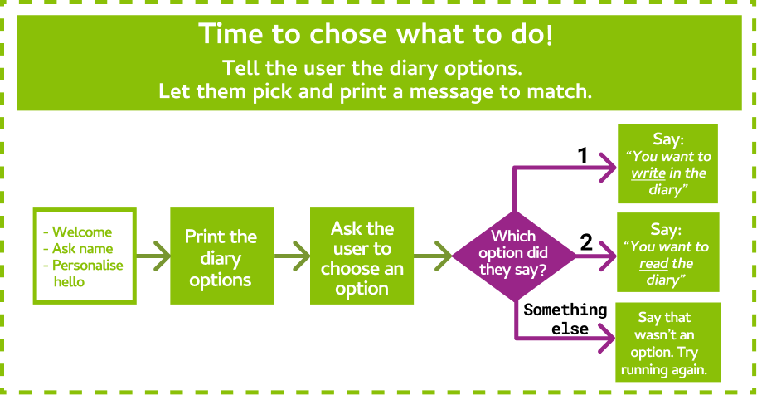

| **Part 2 final code** |
| --- |
| **print("Welcome to the Secret Diary Chatbot!")**  **name = input("What is your name? ")**  **print("Hello " + name)**    **action = input("""**  **What would you like to do?**  **1) Write in the diary**  **2) Read the diary**  **""")**  **if action == "1":**  **print("You want to write in the diary")**  **elif action == "2":**  **print("You want to read the diary")**  **else:**  **print("I don't know what you want to do! Run the program again and say either 1 to write or 2 to read")** |

| **Task 2.1: Welcome to the Secret Diary** |
| --- |
| Our Secret Diary Chatbot protects our secret diary! We can either read what’s in it or add something new.  Use **input** to ask the user what they would like to do with the secret diary. They can either type a 1 to write in the diary, or a 2 to read the diary. Store the answer in a variable called **action**.  For example, your code might print:  **What would you like to do?**  **(1) Write in the diary**  **(2) Read the diary?** |
| ***Hint: Multi-line Print statements*** |
| You can print multiple lines of text in one print statement by using triple quotes like this: print(""" Here is a line of text Here is some more text on a new line  Here is a third line of text """) |
| **Code for section** |
| action = input(""" What would you like to do? 1) Write in the diary 2) Read the diary""") |

| **Task 2.2: Do you want to write?** |
| --- |
| First let’s check to see if the user wanted to write in the diary.   1. Create an **if** statement that checks to see if the user entered **"1"** for the **action** to write in the secret diary. 2. If they did, **print** something to let them know. For example:   **You want to write in the diary!** |
| ***Hint: If Statements*** |
| You can check to see **if** it’s raining like this:  **if raining == "true":**  **print("It’s raining!")** |
| **Code for section** |
| if action == "1":  print("You want to write in the diary") |

| **Task 2.3: Do you want to read?** |
| --- |
| Now let’s check to see if the user wanted to write in the diary.   1. Add an **elif** statement that checks to see if the user entered **"2"** for the **action** to read the secret diary. 2. If they did, **print** something to let them know. For example:   **You want to read the diary!** |
| **Code for section** |
| elif action == "2":  print("You want to read the diary") |

| **Task 2.4: I don’t understand!** |
| --- |
| If they put in something else, then we don’t know what they want!  Add an **else** statement to tell the user something like:   **I don't know what you want to do! Run the program again and say either 1 to write or 2 to read** |
| **Code for section** |
| else:  print("I don't know what you want to do! Run the program again and say either 1 to write or 2 to read") |

| **CHECKPOINT** |
| --- |
| **If you can tick all of these off you can go to Part 3:**  ☐ You have asked the user what they would like to do with the diary.  ☐ If the user selects option 1, the program prints out that they can   write a new line of text to the diary.  ☐ If the user selects option 2, the program prints out that they can   read the diary.  ☐ If the user says anything else, we tell them that we don’t   understand. |

# **Part 3: Writing in the Diary**



| **Part 3 final code** |
| --- |
| **print("Welcome to the Secret Diary Chatbot!")**  **name = input("What is your name? ")**  **print("Hello " + name)**    **action = input("""**  **What would you like to do?**  **1) Write in the diary**  **2) Read the diary**  **""")**  **if action == "1":**  **print("You want to write in the diary")**  **diary_entry = input("What is your message? ")**  **diary_entry = diary_entry + "\n"**  **diary = open("secret_diary.txt", "a")**  **diary.write(diary_entry)**  **diary.close() #text won't be written to file without this line**  **elif action == "2":**  **print("You want to read the diary")**  **else:**  **print("I don't know what you want to do! Run the program again and say either 1 to write or 2 to read")** |

| **Task 3.1: Tell me your secret** |
| --- |
| Time to find out what the user wants to write in the diary!   1. Find your **if** statement that checks if you want to write in the diary 2. Inside the if statement, use **input** to ask the user "What do you want to write? ". Store it in a variable called **diary_entry.** |
| **Code for section** |
| **diary_entry = input("what is your message? ")** |

| **Task 3.2: Open the diary!** |
| --- |
| We need to **open** a file to store our diary in!  *To keep adding to the end of the file we’ll open it in a mode called* ***append****.*   1. Create a new line after you ask the user for their **diary_entry.** 2. Add a line of code that opens the diary in append mode. The diary is in the file called **"secret_diary.txt"**   The file will be created in the same location as your **chatbot.py** file on your computer. |
| ***Hint: Opening a File*** |
| **For example** you can open a file in append mode like this:  **groceries = open("groceries.txt", "a")** |
| **Code for section** |
| **diary = open("secret_diary.txt", "a")** |

| **Task 3.3: Writing our secrets!** |
| --- |
| Now that we have the diary open, we can write our secrets into the diary!     1. We want each diary entry to be on its own line, so first we need to add a special symbol called the “newline character” to the end of **diary_entry** like this: **diary_entry = diary_entry + "\n"** 2. Write the line of code that will **write** the **diary_entry** into the open diary file. |
| ***Hint: Writing to a File*** |
| **For example** we can write a line into a file like this:  **groceries.write("Eggs")** |
| **Code for section** |
| **diary_entry = diary_entry + "\n"**  **diary.write(diary_entry + "\n")** |

| **Task 3.4: Close the diary!** |
| --- |
| It’s really important that we close the text file when we’re finished with it!  **close** the diary. |
| ***Hint: Closing a File*** |
| **For example** you can close a file like this:  **groceries.close()** |
| **Code for section** |
| **diary.close()** |

| **CHECKPOINT** |
| --- |
| **If you can tick all of these off you can go to Part 4:**  ☐ When the user answers “1” they can tell the program what they   want to write in the diary  ☐ After you write something in the diary, if you open the file on your   computer, it will have the new thing you wrote  ☐ If you run the program again and write another thing and open the   file on your computer, it will have the old thing you wrote AND the   new thing |

# **Part 4: Reading the Diary**

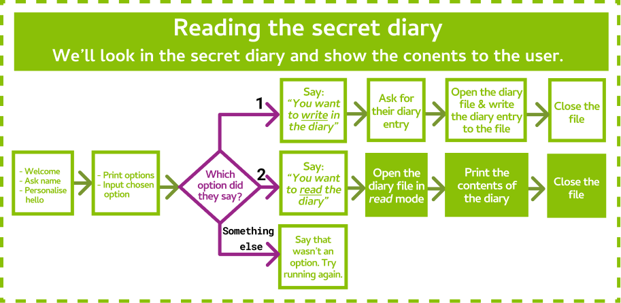

| **Part 4 final code** |
| --- |
| **print("Welcome to the Secret Diary Chatbot!")**  **name = input("What is your name? ")**  **print("Hello " + name)**    **action = input("""**  **What would you like to do?**  **1) Write in the diary**  **2) Read the diary**  **""")**  **if action == "1":**  **print("You want to write in the diary")**  **diary_entry = input("What is your message? ")**  **diary = open("secret_diary.txt", "a")**  **diary_entry = diary_entry + "\n**  **diary.write(diary_entry)**  **diary.close() #text won't be written to file without this line**  **elif action == "2":**  **print("You want to read the diary")**  **diary = open("secret_diary.txt", "r")**  **print(diary.read())**  **diary.close()**  **else:**  **print("I don't know what you want to do! Run the program again and say either 1 to write or 2 to read")** |

| **Task 4.1: Open the diary!** |
| --- |
| So we can read what’s in the diary, we need to open it in a mode called **read**.   1. Find your **elif** statement that checks if you want to *read* the diary 2. Add a line of code that will open the diary in read mode.   *This is a lot like when we opened the diary to write in it, but we’re using a different mode.* |
| ***Hint: Opening a File*** |
| **For example** you can open a file in *read mode* like this:  **readmeFile = open("readme.txt", "r")** |
| **Code for section** |
| **diary = open("secret_diary.txt", "r")** |

| **Task 4.2: Read the diary!** |
| --- |
| It’s time to show the user what’s inside the diary!  **print** out the contents of the diary to the user. |
| ***Hint: Reading a File*** |
| **For example** you can read the contents of a file like this:  **contents = readmeFile.read()** |
| **Code for section** |
| **content = diary.read()**  **print(content)**  **Alternatively, print(diary.read())will do it in one line** |

| **Task 4.3: Close the diary!** |
| --- |
| Just like before, it’s really important that we close the text file when we’re finished with it!  **close** the diary. |
| **Code for section** |
| **diary.close()** |

| **CHECKPOINT** |
| --- |
| **If you can tick all of these off you can go to Part 5:**  ☐ When you say “2” it will print out everything that’s written in the diary!  ☐ Run it again to write something new in the diary. Then run and view   the diary to see the updated contents. |

# 

# **Part 5: It’s a SECRET Diary!**

| **Part 5 final code** |
| --- |
| password = "open_sesame"  access_type = None  print("Welcome to the secret diary.")  name = input("What is your name? ")  print("Hello " + name)  guessed_password = input("What's the password? ")  wrong = 0  while access_type == None:  if wrong == 3:  access_type = "denied"  print("Too many guesses!")  if guessed_password == password:  access_type = "allowed"  else:  wrong = wrong + 1  guessed_password = input("What's the password? ")  if access_type == "allowed":  action = input(**"""**  What would you like to do?  1) Write in the diary  2) Read the diary  """)  if action == "1":  print("You want to write in the diary")  diary = open("secret_diary.txt", "a")  diary_entry = input("What is your message? ")  diary.write(diary_entry + "\n")  diary.close()  elif action == "2":  print("You want to read the diary")  diary = open("secret_diary.txt", "r")  print(diary.read())  diary.close()  else:  print("I don't know what you want to do! Run the program again and say either 1 to write or 2 to read")  elif access_type == "denied":  print("No access for you!") |



| **Task 5.1: Let’s make a password** |
| --- |
| It’s way too easy to get to the secret diary! We have no security! Let’s add some in with a password.   1. Add a variable called **password** at the start of the file. 2. Make it equal a password like “I love GPN” 3. Add a variable called **access_type** that will store whether the user is allowed to access the diary or not. Set it to **None**. *This is like saying it is empty.* |
| **Code for section** |
| password = "open_sesame"  access_type = None |

| **Task 5.2: What’s the password?** |
| --- |
| Let’s ask the user if they know what the secret password is!   1. Find the point after the user gives their name, but before we ask what they want to do with the diary. 2. Use **input** to ask the user "what is the secret password? ". Store their answer in a variable called **guessed_password**. |
| **Code for section** |
| guessed_password = input("What's the password? ") |

| **Task 5.3: Guessing Game** |
| --- |
| The user might not get the password right on the first try. They might have made a typo! Let’s give them some chances to get the password right.   1. Create a **while** loop that checks if the **access_type** is still **None.** 2. Inside the **while** loop create an **if** statement that checks if the guessed_password is correct. 3. If the guessed password is correct, set the **access_type to "allowed"** 4. But if it’s not right we want to ask again, in case they made a typo. Add an **else** statement to your **if** statement which asks them to enter the password again. Store the new guess in the same variable as before, **guessed_password.** |
| ***Hint: While Loops*** |
| You can keep asking questions in a **while** loop like this:  **while answer != "4":**  **answer = input("What number am I thinking of? ")** |
| **Code for section** |
| while access_type == None:  if guessed_password == password:  access_type = "allowed"  else:  guessed_password = input("What's the password? ") |

| **Task 5.4: Too Many Guesses** |
| --- |
| Right now, we keep asking the user what the **password** is until they get it right! This means that the user can keep guessing forever.   1. Create a variable called **wrong** just above the **while** loop and set it to **0**. 2. Go to your **else** statement where they get asked to try the password again. In the **else** statementadd 1 to **wrong** before they get to guess again so that we can count how many times they get the password wrong. |
| **Code for section** |
| **wrong = 0**  while access_type == None:  if guessed_password == password:  access_type = "allowed"  else:  **wrong = wrong + 1**  guessed_password = input("What's the password? ") |

| **Task 5.5: Locking your diary** |
| --- |
| Right now, we keep asking the user what the **password** is until they get it right! This means that the user can keep guessing forever.   1. Add an **if** statement at the top of (inside) your **while** loop, that checks if **wrong** is equal to 3. 2. Inside that **if** statement, set the **access_type** to **"denied"**. Print that they had too many guesses.   Now the user will only get 3 attempts to get the password right, before being locked out! |
| **Code for section** |
| wrong = 0while access_type == None: **if wrong == 3:** **access_type = "denied"** **print("Too many guesses!)** if guessed_password == password: access_type = "allowed" else:wrong = wrong + 1 guessed_password = input("What's the password? ") |

| **Task 5.6: Different access** |
| --- |
| We need to check what the access type is before we let them use the diary!   1. Add an **if** statement after the **while** loop that checks if the **access_type** is **"allowed"** 2. Put all of the code below that lets the user read and write to the Secret Diary inside of that **if** statement so that it only runs when they are allowed to have access. 3. After that **if** statement, make an **elif** statement that checks if the **access_type** is **"denied"** and **print** something to tell them that they’re locked out of the Diary |
| **Code for section** |
| **if access_type == "allowed":**  action = input("What would you like to do?\n1) Write\n2) Read")  if action == "1":  print("You want to write in the diary")  diary = open("secret_diary.txt", "a")  diary_entry = input("what is your message? ")  diary.write(diary_entry + "\n")  diary.close()  elif action == "2":  print("You want to read the diary")  diary = open("secret_diary.txt", "r")  print(diary.read())  diary.close()  else:  print("not an option")  **elif access_type == "denied":**  **print("No access for you!")** |

| **CHECKPOINT** |
| --- |
| **If you can tick all of these off you can go to Part 6:**  ☐ You have a password.  ☐ You keep asking the user for the password until they enter the right one or have guessed too many times.  ☐ Once they get the password right they can use the diary! |

# **Part 6: It’s a trap!**

Sometimes siblings like to get in your stuff, so we’re going to set a trap for anyone trying to sneak into our secret diary. Let’s make a decoy password that shows them a fake diary.

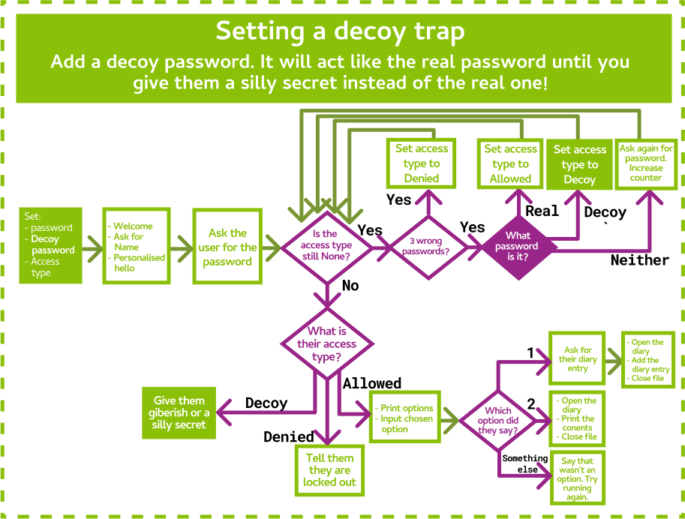

| **Part 6 final code** |
| --- |
| password = "open_sesame"  decoy_password = "abc123"  access_type = None  print("Welcome to the secret diary.")  name = input("what is your name? ")  print("Hello " + name)  guessed_password = input("What's the password? ")  wrong = 0  while access_type == None:  if wrong == 3:  access_type = "denied"  print("Too many guesses!")  if guessed_password == password:  access_type = "allowed"  elif guessed_password == decoy_password:  access_type = "decoy"  break  else:  wrong = wrong + 1  guessed_password = input("What's the password? ")  if access_type == "allowed":  action = input("What would you like to do?\n1) Write\n2) Read")  if action == "1":  print("You want to write in the diary")  diary = open("secret_diary.txt", "a")  diary_entry = input("what is your message? ")  diary.write(diary_entry+ "\n")  diary.close()  elif action == "2":  print("You want to read the diary")  diary = open("secret_diary.txt", "r")  print (diary.read())  diary.close()  else:  print("I don't know what you want to do! Run the program again and say either 1 to write or 2 to read")  elif access_type == "decoy":  print("The secret is I like pie")  elif access_type == "denied":  print("No access for you!") |

| **Task 6.1: Decoy Password** |
| --- |
| 1. In the same place that you set **password**, make a new variable called **decoy_password** and set it to something else that you think your friends or siblings might guess |
| **Code for section** |
| decoy_password = "abc123" |

| **Task 6.2: Let them through!** |
| --- |
| If they guess the **decoy_password** while they are trying to get into the secret diary, we want to give them a new access type.  Add an **elif** statement inside the while loop after the one that checks if the password is right that checks if the **guessed_password** is the decoy and sets the **access_type** to **"decoy”** |
| **Code for section** |
| while access_type == None:  if wrong == 3:  access_type = "denied"  print("Too many guesses!)  if guessed_password == password:  access_type = "allowed"  **elif guessed_password == decoy_password:**  **access_type = "decoy"**  **break**  else:  wrong = wrong + 1  guessed_password = input("What's the password? ") |

| **Task 6.3: Fake news!** |
| --- |
| We need to make sure that if they guessed the **decoy_password**, they don’t get into our real diary and get a fake diary instead!   1. Create another **elif** statement after the **if** that checks if they are **”denied”** and make it check if the **access_type** is equal to **”decoy”** 2. Inside the **elif** statement, print out whatever you want the fake diary to be! For example: **Here's the secret diary (I hope you can read gibberish!)**   **aghioahgiagipsjgij sagagieja iahgoaihg aoireioaghoiag io** |
| **Code for section** |
| **elif access_type == "decoy":**  **print("The secret is I like pie")** |

| **CHECKPOINT** |
| --- |
| **If you can tick all of these off you can go to the Extensions:**  ☐ You have a decoy password  ☐ When the user puts in the decoy password they see the fake diary ☐ When the user puts in the real password they can still get the real diary |

# **Extension 7: What’s your style?**

| **Task 7.1: Give it a fun theme!** | |
| --- | --- |
| In the instructions, we’ve based it on keeping a secret diary safe from our little siblings! **But you can add your own theme!!**  **Think about a theme you want to add to your chatbot! Some ideas are below!!** | |
| **A spy theme!!**  The chatbot protects the secret identities and speaks like a secret agent. | **A secret club for a school project!!**  Keep copycats at bay and teach them a lesson for trying to steal your ideas! Teach cheaters a lesson! |
| **Pokemon Go!!** Use your chatbot to store the secret locations of rare pokemon! | **A fight between Good and Evil!**  Every team has to store their secret info somewhere whether they are in Dumbledore’s Army, The Rebel Alliance or the Powerpuff Girls! |

| **Task 7.2: S-S-S-Style!** |
| --- |
| Use your theme!   1. Change, or add in more print statements to reflect your chosen theme! 2. Change your questions and answers so they match the theme as well! |

# **Extension 8: Intelligent Checks!**

| **Final base workbook + Intelligent Check extension** |
| --- |
| password = "open_sesame"  access_type = None  print("Welcome to the secret diary.")  name = input("what is your name? ")  print("Hello " + name)  guessed_password = input("What's the password? ")  wrong = 0  while access_type == None:  if wrong == 3:  access_type = "denied"  print("Too many guesses!)  if guessed_password == password:  access_type = "allowed"  else:  wrong = wrong + 1  guessed_password = input("What's the password? ")  **answer = input("What's 2 + 2")**  **if answer != 4:**  **print("You're not smart enough to look at the secret diary!")**  **exit()**    if access_type == "allowed":  action = input("What would you like to do?\n1) Write\n2) Read")  if action == "1":  print("You want to write in the diary")  diary_entry = input("what is your message? ")  diary_entry = diary_entry = "\n"  diary = open("secret_diary.txt", "a")  diary.write(diary_entry)  diary.close()  elif action == "2":  print("You want to read the diary")  diary = open("secret_diary.txt", "r")  print(diary.read())  diary.close()  else:  print("not an option")  elif access_type == "denied":  print("No access for you!") |

| **Task 8.1: You’re so smart!** |
| --- |
| You know lots of things and you can prove it! Let’s add another level of security that checks if you are smart enough to read the diary.   1. Find the part of the code after the while loop that checks the password. 2. Use **input** to ask the user the answer to an intelligence question. For example: **"What is 2 + 2? "** and store it in a variable called **answer** |

| **Task 8.2: Or are you?** |
| --- |
| Now we need to check whether or not the answer is right!   1. Write an **if** statement that checks if the **answer** that they gave does NOT equal the right answer. 2. If the answer is wrong, **print** something to let them know that they aren’t smart enough to get into your diary and use **exit()** to make the program stop right there. |

| **Task 8.3: I know lots of things!** |
| --- |
| You can add as many of these questions as you want by copying your code from 8.1 and 8.2 and changing the question and answer! See if the person next to you can get past your intelligence checks! |

# 

# 

# **Extension 9: Random Maths questions!**

| **Final base workbook with Intelligent check extension + Random Maths Questions** |
| --- |
| **import random**  password = "open_sesame"  decoy_password = "abc123"  access_type = None  **num1 = random.randint(1,10)**  **num2 = random.randint(1,10)**  **answer = num1 + num2**  **question = f"What is the sum of {num1} and {num2}? "**  print("Welcome to the secret diary.")  name = input("what is your name? ")  print("Hello " + name)  guessed_password = input("What's the password? ")  wrong = 0  while access_type == None:  if wrong == 3:  access_type = "denied"  print("Too many guesses!)  if guessed_password == password:  access_type = "allowed"  **user_answer = int(input(question))**  **if user_answer == answer:**  **access_type = "allowed"**  **print("that is correct")**  **else:**  **access_type = "denied"**  elif guessed_password == decoy_password:  access_type = "decoy"  break  else:  wrong = wrong + 1  guessed_password = input("What's the password? ")  answer = input("What's 2 + 2")  if answer != 4:  print("You're not smart enough to look at the secret diary!")  exit()    if access_type == "allowed":  action = input("What would you like to do?\n1) Write\n2) Read")  if action == "1":  print("You want to write in the diary")  diary_entry = input("what is your message? ")  diary = open("secret_diary.txt", "a")  diary_entry = diary_entry = "\n"  diary.write(diary_entry)  diary.close()  elif action == "2":  print("You want to read the diary")  diary = open("secret_diary.txt", "r")  print(diary.read())  diary.close()  else:  print("I don't know what you want to do! Run the program again and say either 1 to write or 2 to read")  elif access_type == "decoy":  print("The secret is I like pie")  elif access_type == "denied":  print("No access for you!") |

Note: only do this if you have already done Extension 8!

| **Task 9.1: That’s so random!** |
| --- |
| Let’s generate some random maths questions for security, so they change every time! We’ll use the random module!  If you haven’t already, at the top of your code, **import random**.. |

| **Task 9.2: Number Generator!** |
| --- |
| Now we need to generate the numbers for the maths question! Let’s get the answer at the same time.   1. Randomly choose a number between **1** and **10**, and store it in a variable called **num1**. 2. Randomly choose another number between **1** and **10**, and store it in a variable called **num2**. 3. Add the two numbers together, and store it in a variable called **answer**. |

| **Task 9.3: Question Creation** |
| --- |
| Now we need to create the question, so we can ask it.   1. Make a String that asks what happens when you add **num1** and **num2** together. Store it in a variable called **question**. 2. Ask the user for input, using the question variable you just made as the prompt. Store the answer in a variable called **user_answer** |

| **Task 9.4: Am I right?** |
| --- |
| Now we need to check their response.   1. Add an **if** statement that checks if the **user_answer** is the same as the actual **answer** 2. If the **user_answer** is the same as **answer**, print that they got it right and set the **access_type** to **"allowed"** 3. Add an else statement that changes the **access_type** to either **"denied"** or **"decoy"** |

# **Extensions 10: Make it Funnier!**

| **Final base workbook with Intelligent check extension + Random Maths Questions** |
| --- |
| **import random**  password = "open_sesame"  decoy_password = "abc123"  access_type = None  **answers = ["Yes", "No", "Maybe"]**  print("Welcome to the secret diary.")  name = input("what is your name? ")  print("Hello " + name)  guessed_password = input("What's the password? ")  wrong = 0  while access_type == None:  if wrong == 3:  access_type = "denied"  print("Too many guesses!")  if guessed_password == password:  **access_type = "allowed"**  elif guessed_password == decoy_password:  access_type = "decoy"  **print(r"""**  **/\_/\**  **>^.^<.---.**  **_'-`-' )\**  **(6--\ |--\ (`.`-.**  **--' --' ``-'**  **""")**  break  else:  wrong = wrong + 1  guessed_password = input("What's the password? ")  answer = input("What's 2 + 2")  if answer != 4:  print("You're not smart enough to look at the secret diary!")  exit()    if access_type == "allowed":  action = input("What would you like to do?\n1) Write\n2) Read")  if action == "1":  print("You want to write in the diary")  diary_entry = input("what is your message? ")  diary = open("secret_diary.txt", "a")  diary_entry = diary_entry = "\n"  diary.write(diary_entry)  diary.close()  elif action == "2":  print("You want to read the diary")  diary = open("secret_diary.txt", "r")  print(diary.read())  diary.close()  else:  print("I don't know what you want to do! Run the program again and say either 1 to write or 2 to read")  elif access_type == "decoy":  while True:  input("What is your question? ")  print(random.choice(answers))  elif access_type == "denied":  print("No access for you!") |

| **Task 10.1: More security, more!** | |
| --- | --- |
| Think about jokes and tricks to add to your chatbot when the user guesses the decoy password. Some ideas are below! If you haven't done extension 6 yet, do that first and come back. | |
| **A Magic 8 Ball!**  Trick imposters into thinking that your secret is a magic 8 ball. Distract the imposter with your magic 8 ball!  **Ask the magic 8 ball for advice: Will it rain today?**  **>>> Yes**  **Ask another question: Should I go shopping?**  **>>> Maybe**  **Ask another question: Will it rain today?**  **>>> Ask again later** | **ASCII Art** Add some ASCII art for fun!!!  **Here is the super secret info ...**  **_=,_  o_/6 /#\\  \__ |##/  ='|--\\  / #'-.  \#|_ _'-. /  |/ \\_( # |"   C/ ,--___/**  **Woof...** |

| **Task 10.2: Magic 8 Ball** |
| --- |
| Let's create a Magic 8 Ball!   1. At the top of your code, **import random**. This will let us choose things randomly! 2. Create a **list** called **answers**. Add in some Magic 8 answers to this list, like **"Yes"**, **"No"**, or **"Maybe"**. Add as many answers to this list as you like! 3. Use **input** to ask the user what question they'd like the answer to. 4. Use **random.choice** to select an answer from the answers list. Tell the user! 5. Add a **while** loop, so your code keeps asking questions and giving random answers. |
| ***Hint: Lists*** |
| You can create a list of your favourite foods like this:  **myFave =** **["pizza", "chocolate", "nutella", "lemon"]** |
| ***Hint: Random choice*** |
| You can use **random.choice** to select a random number between 1 and 3 like this:  **mynum = random.choice([1, 2, 3])** |
| **Code for section** |
| **#import random at the top**  **import random**  **…**  **answers = ["Yes", "No", "Maybe"]**  **# Change the decoy password if statement like this**  **if guessed_password == decoy_password:**  **while True:**  **input("Ask the magic 8 ball for advice. Enter a question: ")**  **print(random.choice(answers))** |

| **Task 10.3: ASCII art** |
| --- |
| Let's show some ASCII art to our secret agents!   1. Pick some ASCII art! You can choose from <http://www.ascii-art.de/ascii/>, or make your own! 2. Copy and paste it into your program. You will need to **print** your ASCII art.   ***Note:*** If your picture doesn't print out exactly as you expect you might have quotes inside it that are breaking your print. Edit the picture, or choose another! |
| ***Hint:*** |
| You can use 2 special tricks to print your art:   * triple quotes to **print** things on multiple lines using one **print** statement. * Put the letter r just before your multiline string. This makes it a **raw** string.  *Normal strings do special things with characters like* **"\"***. We don’t want that.*   **print(r"""This is**  **A really really**  **Long answer""")** |
| **Code for section** |
| **# Change the decoy password if statement like this**  **if guessed_password == decoy_password:**  **print(r"""**  **/\_/\**  **>^.^<.---.**  **_'-`-' )\**  **(6--\ |--\ (`.`-.**  **--' --' ``-'**  **""")** |

# **Extension 11: Em🍊jifacti🍊n Functi🍊n**

Right now our diary is protected from snoops when they use the chatbot, because they need the password. **But what if someone just goes and opens the text file and reads it!**

We’ll make our words unreadable by encoding them with emoji!

| **Task 11.1: Emoji-fy function** |
| --- |
| Let’s write a function that will convert messages to emoji-fied messages   1. Define a function called **emojify** that takes 1 parameter, the **message** we want to put emoji’s into. 2. We’ll start by replacing all of the letter “a” with the 🍎 emoji using this line of code: **message = message.replace("a", "🍎")** To get the emoji you can go to <https://emojityper.com/>, search for apple and copy it. 3. Return the message (which is now apple-ified!) |

| **Task 11.2: Emoji-fy your diary!** |
| --- |
| Time to use our emojify function before we store our secret diary entry   1. Go to the place in your code after you ask the user for their diary entry. (before you write it to the diary file). Use the emojify function on the diary_entry and then write the emojified entry to the file. 2. Emoji are different to normal letters so we need to tell Python to do things a little differently when we write to the file. Add **encoding = "utf-8"** at the end of your file open command so it looks like this: **open("secret_diary.txt", "a", encoding="utf-8")** 3. Test your code!    * Run your code, and add a new message  (make sure it includes the letter “a”)    * Look in your secret diary file by hand, does it have an apple?    * Try and read your diary with your program.  *…. Whoops there’s still apples there. We haven't written the decoder yet!* |

| **Task 11.3: De-emojify function!** |
| --- |
| We want to read the diary again so we need to put the letters instead of emoji back in!   1. Start a new function called **demojify**, which takes one parameter, the content you want to put letters back into. 2. We’ll do the opposite of what we did before. Use replace again. But this time replace **"🍎"** with **"a"**. *(switch the order from before)* |

| **Task 11.4: De-emoji-fy your diary!** |
| --- |
| Now to use the demojify function to make our diary readable again!   1. Go to the place in your code after you read the content of the diary. Use the demojify function to get put the letters back in the text. Then print out the content. 2. Add the **encoding = "utf-8"** code when you open the file for reading here too! It should look like **open("secret_diary.txt", "r", encoding="utf-8")** 3. Test your code!    1. Run your code, and add a new message (enter a message with an “a” in it)    2. Try and read your diary with your program. Are the apples gone? |

| **Task 11.5: More emoji is more secret!** |
| --- |
| The more letters you replace with emoji the harder it will be to understand any words.   1. Repeat the encoding and decoding process above, but for different letters and emoji. You can use *emojityper* to find more emoji to copy. |

| **Final base workbook + Emoji-fy Functions** |
| --- |
| **def emojify(msg):**  **msg = msg.replace("a", "🍎")**  **msg = msg.replace("b", "🍌")**  **return msg**  **def demojify(content)**  **content = content.replace("🍎", "a")**  **content = content.replace("🍌", "b")**  **return content**  **password = "open_sesame"**  **decoy_password = "abc123"**  **access_type = None**  **print("Welcome to the secret diary.")**  **name = input("what is your name? ")**  **print("Hello " + name)**  **guessed_password = input("What's the password? ")**  **while guessed_password != password:**  **guessed_password = input("What's the password? ")**  **action = input("""**  **What would you like to do?**  **1) Write in the diary**  **2) Read the diary**  **""")**  **if action == "1":**  **print("You want to write in the diary")**  **diary_entry = input("what is your message? ")**  **diary = open("secret_diary.txt", "a", encoding="utf-8")**  **diary_entry = emojify(diary_entry)**  **diary.write(diary_entry + "\n")**  **diary.close()**  **elif action == "2":**  **print("You want to read the diary")**  **diary = open("secret_diary.txt", "r", encoding="utf-8")**  **content = diary.read()**  **content =** demojify**(content)**  **# add more un-replacements**  **print(content)**  **diary.close()**  **else:**  **print(**"I don't know what you want to do! Run the program again and say either 1 to write or 2 to read"**)** |

# 

# 